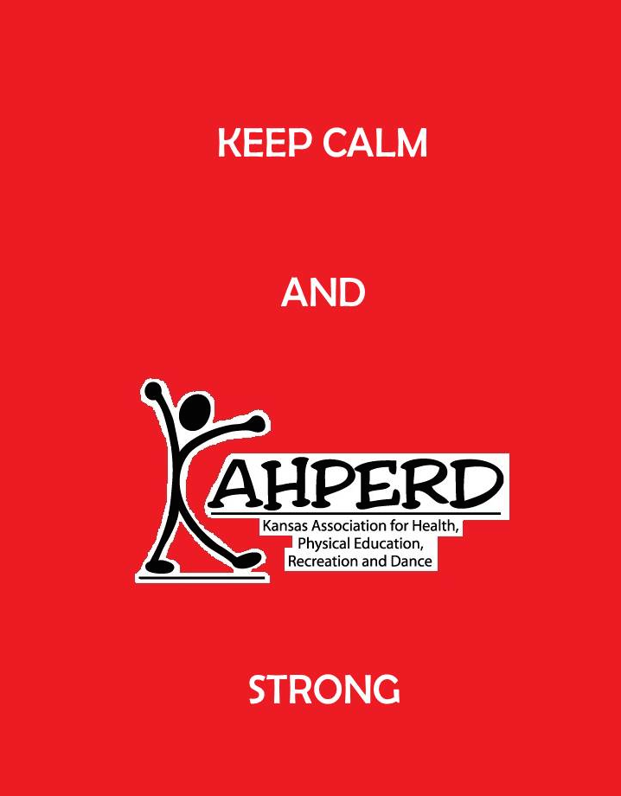
KAHPERD Welcome

The theme for this year is "Keep Calm and KAHPERD Strong”. This theme was originally a motivational poster produced by the British government prior to the beginning of the Second World War, intended to raise the morale of the British public. KAHPERD Council would like to raise the morale of our members to create an organization that will serve its' members and profession to achieve our mission of seeking to promote and advocate for healthy, active Kansans. We encourage our members to share by presenting at workshops and conventions, by nominating deserving members for awards or Council positions, writing letters and meeting legislators advocating for quality health/physical education and to support and promote programs like "Let's Move, Active Schools" (LMAS).
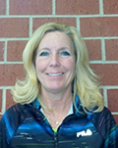
Thank you for attending the 2014 Convention, KAHPERD is glad you are here. You have taken the first step toward helping us achieve our mission. Enjoy the Convention!
KAHPERD Strong!
Kim Morrissey
President, KAHPERD

PSU Welcome

On behalf of the Pittsburg State University Department of Health, Human Performance and Recreation, please let me extend a hearty welcome to each of you. Under the guidance of Dr. Gorman our faculty, staff and majors have worked very hard in preparing for this convention. KAHPERD members are special people and I hope all of you will find this convention to be both educational and enjoyable. Do take the time to make new friends and visit with old acquaintances. If you have any questions or concerns during your time in Pittsburg, feel free to call upon our faculty and students. Pittsburg State University is a great place to visit and we want to prove it. We are at your service.
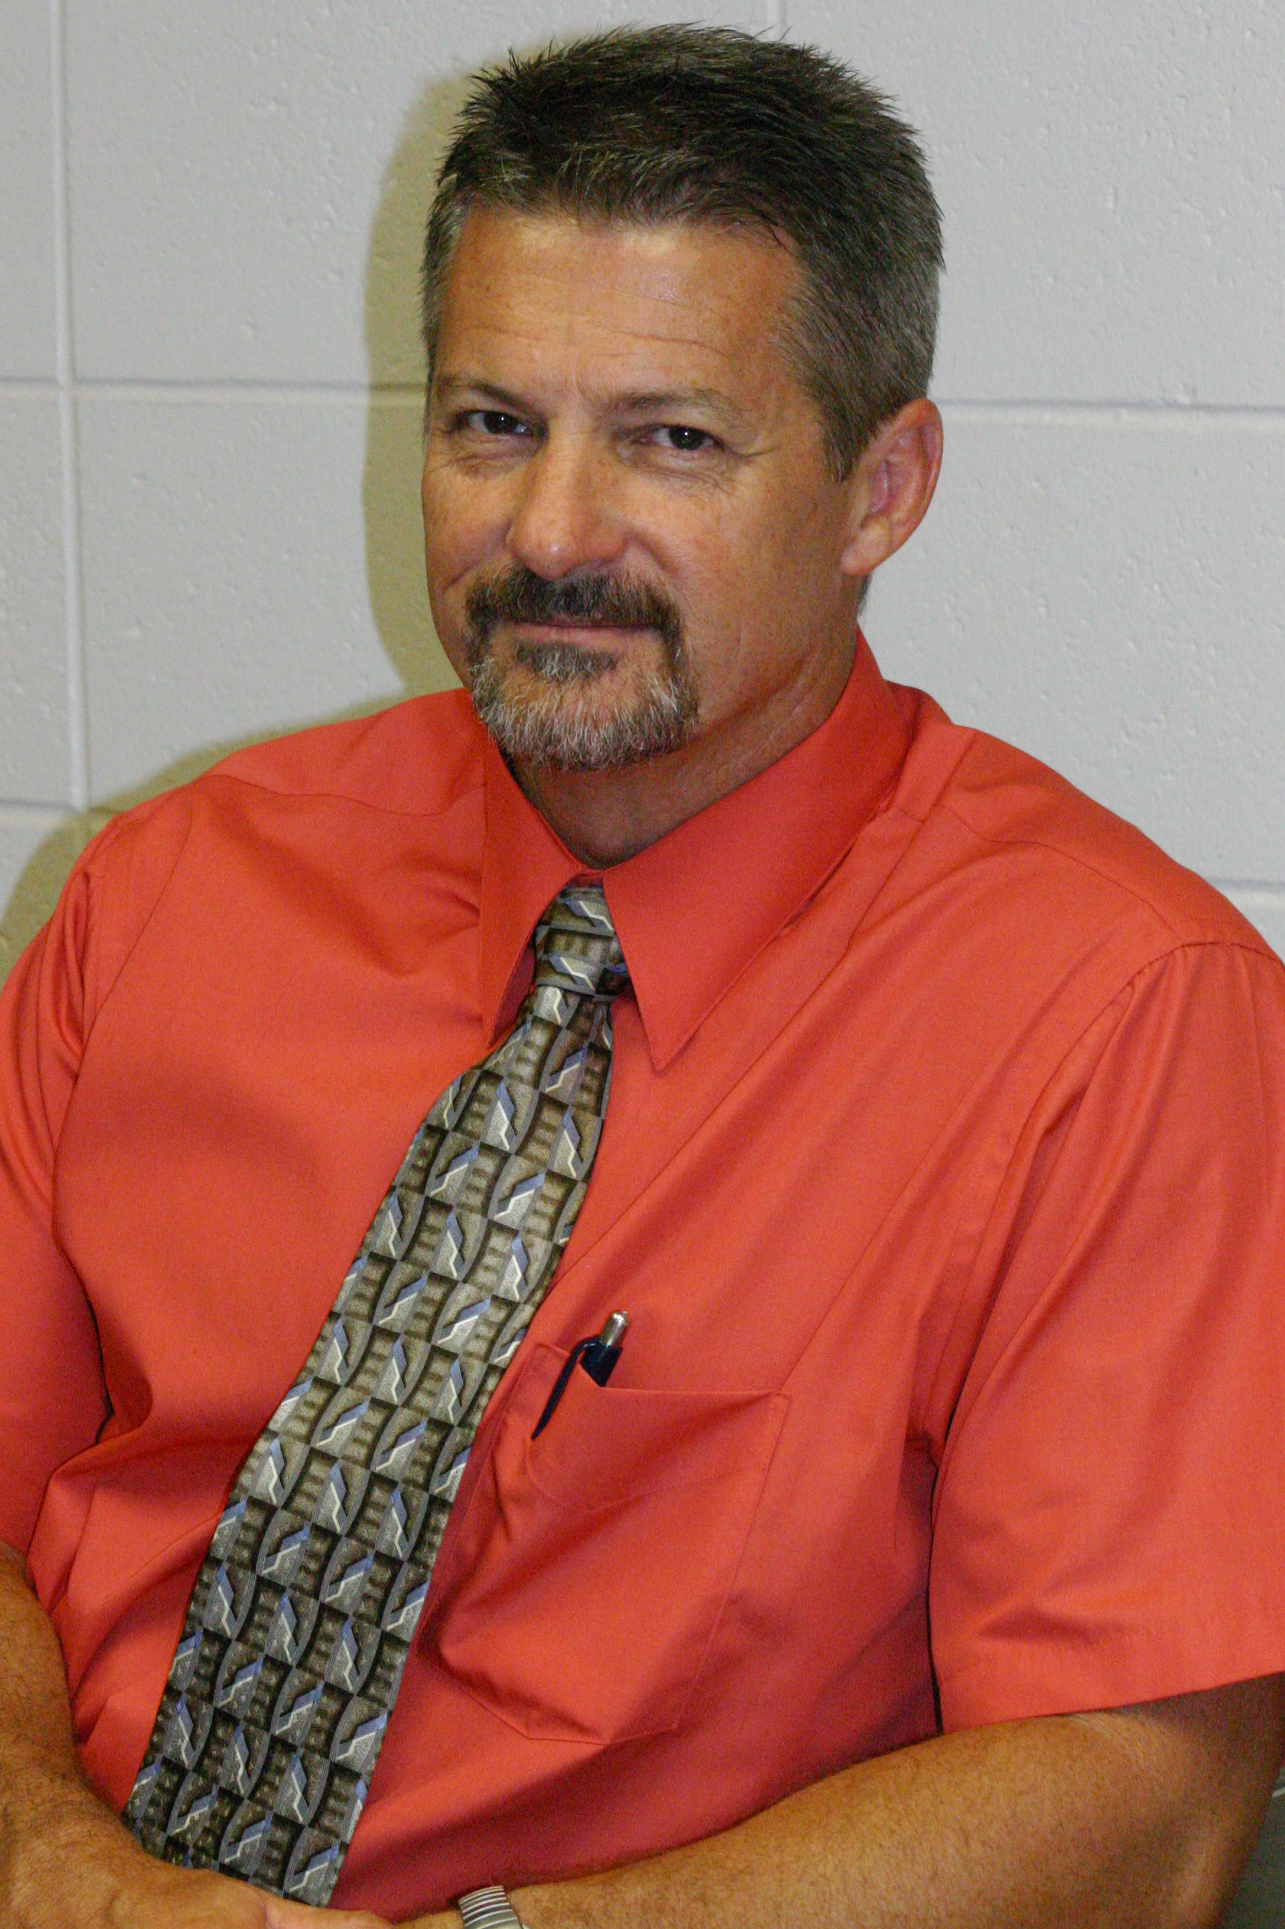
John Oppliger
HHPR Chair

PSU Convention Site Committees/Workers

KAHPERD thanks the following individuals for their contributions in planning
and bringing this convention to fruition:

Convention Managers: Scott Gorman and John Oppliger
Convention Program: Damon Leiss and April Huddleston
Banquet Decorations: Shelly Grimes and Julia Spresser
Parking: Rob Hefley and John Oppliger
Snacks: Laura Covert and Ryan Metcalf
Guest Hospitality: John Oppliger and Karl Hassard
Equipment: Cole Shewmake and Janice Jewett
Registration: April Huddleston and Vicki Worrell
Technology: Kylie Edgecomb and Chris Fleury
Signage: Bill Stobart and Karl Hassard
Exhibits: Mike Carper and Kaylah Williamson
Packet Preparation: Bill Stobart, Rob Hefley, PSU HHPR Majors, Crawford
County Convention and Visitors Bureau
Photographers Julia Spresser, Bill Stobart, Shelly Grimes
Grants: Wendy Scholten
Publicity: B. J. Harris and the Crawford County Convention and
Visitors Bureau
Gifts/Door Prizes: HHPR Faculty
Special Help: PSU HHPR Majors
Facilities: Susan Downing, Vince Daino, Kevin Obungu and the
PSU Student Recreation Center Staff
KAHPERD Executive Council
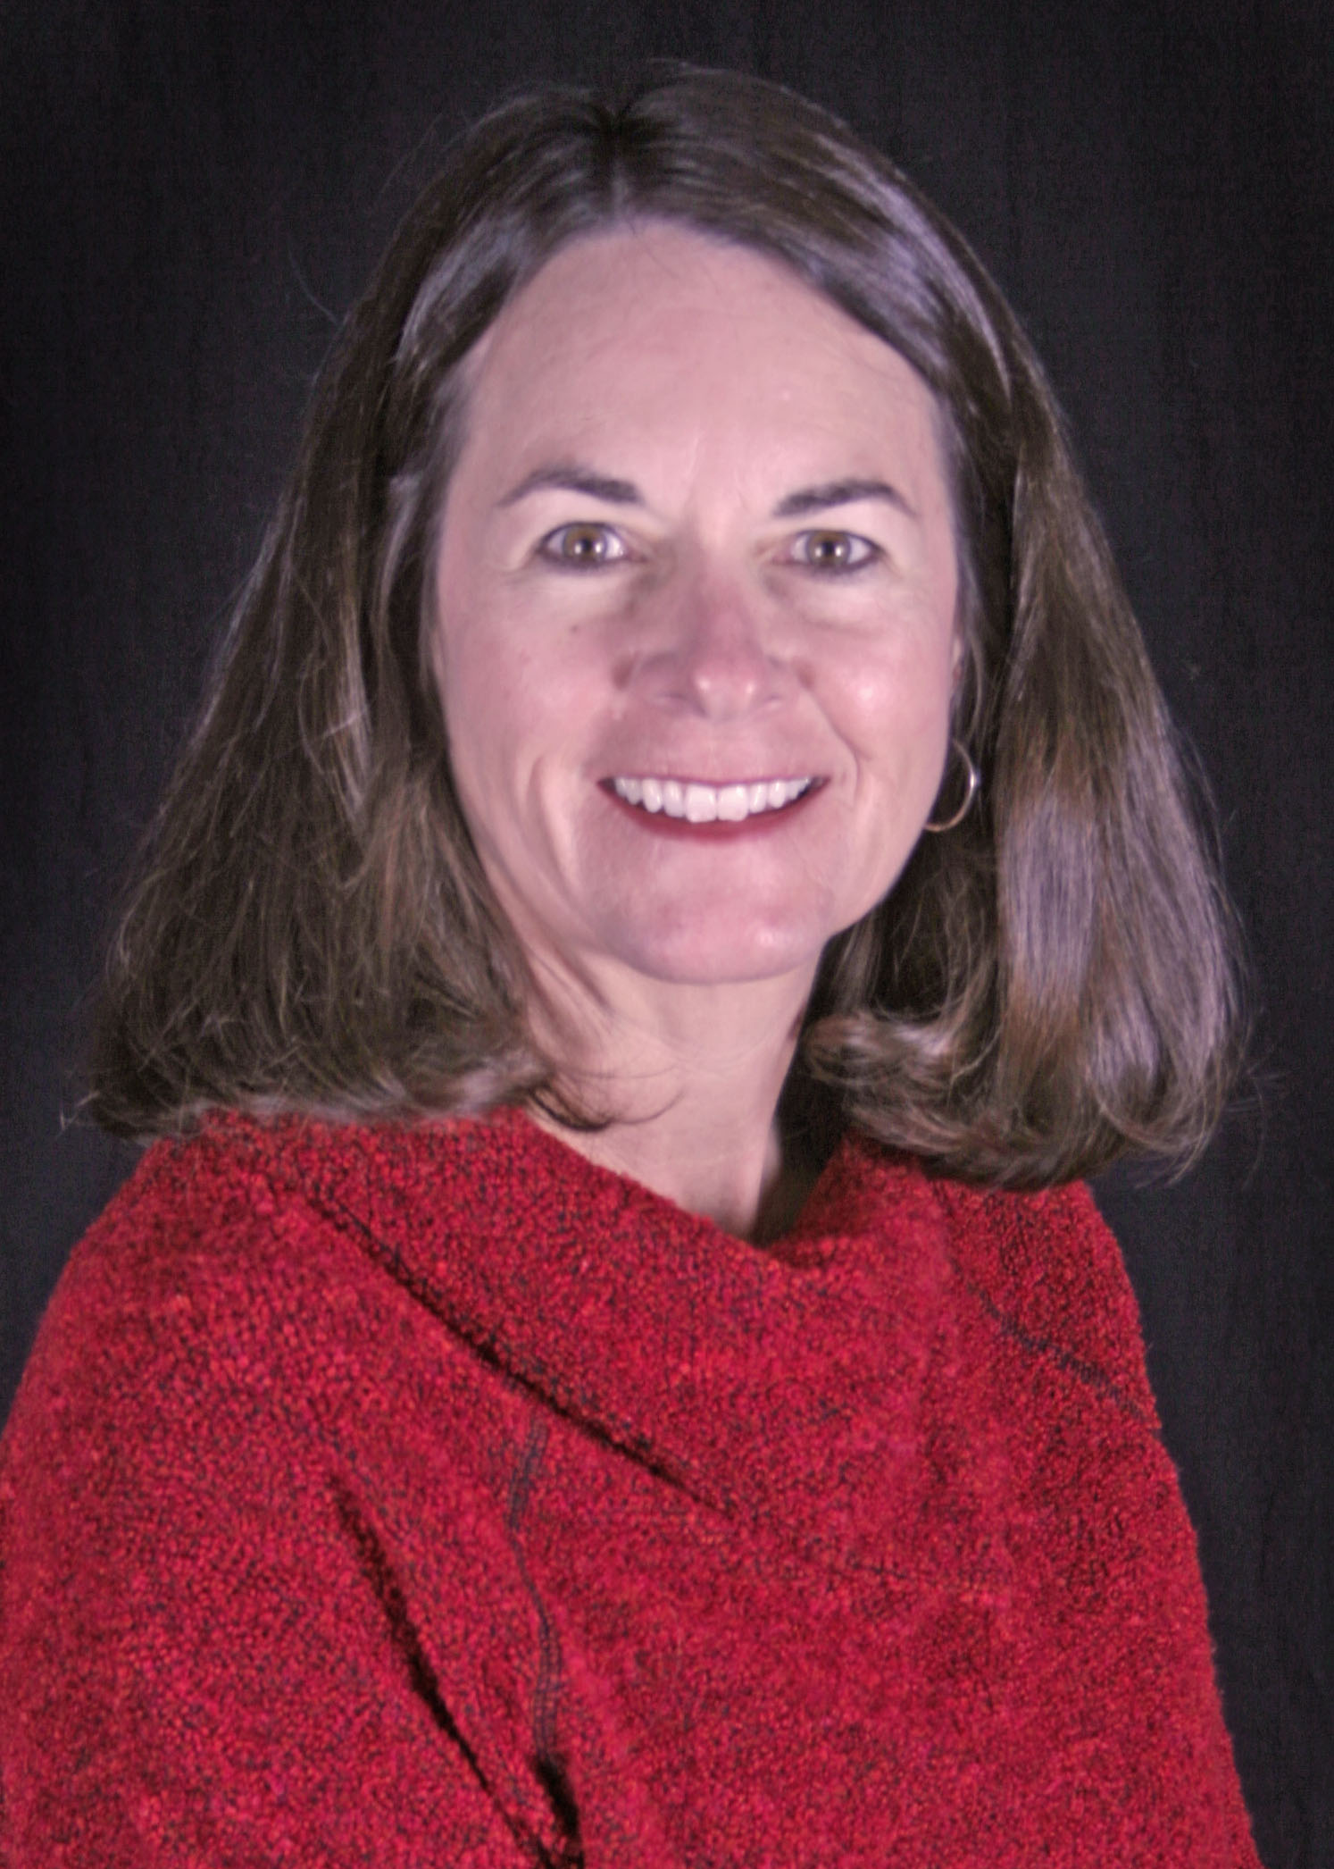
Executive Director
Vicki Worrell
Department of HPER
Emporia State University
Emporia, KS
President
Kim Morrissey
Dodge Literacy Magnet
Wichita, KS
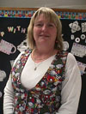
President-Elect
Wendy Scholten
Ridgeview Elementary
Olathe, KS

Past-President
Damon Leiss
ESU Dept. of HPER Box 4013
Emporia, KS 66801
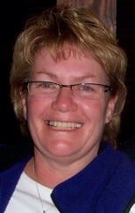
Secretary
Karla Stenzel
AMAC
Wichita, KS

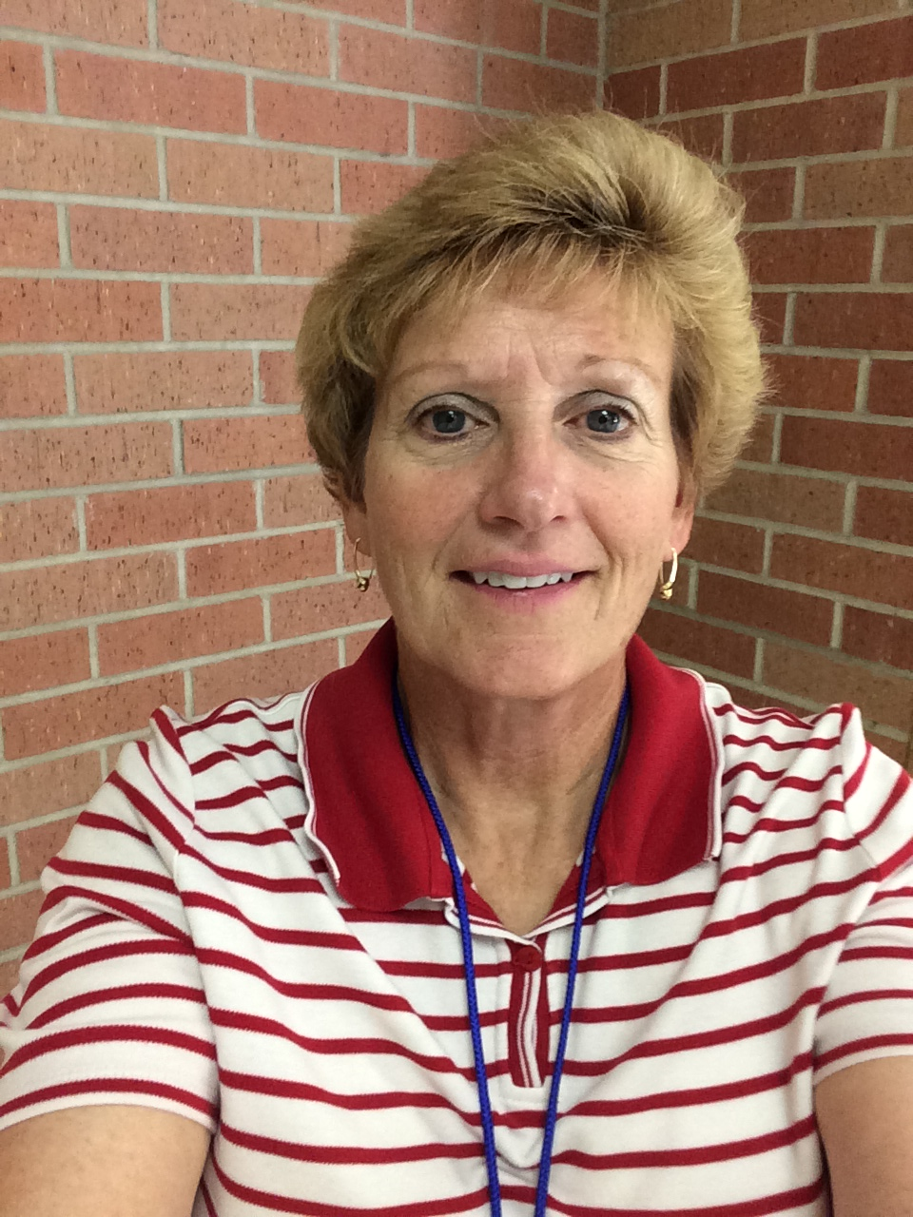
Treasurer
Janelle Robins-Gaede
Holcomb Elementary
Holcomb, KS
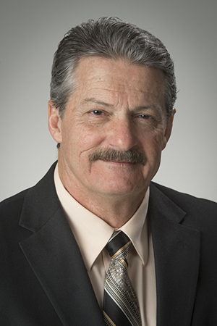
Journal Editors
John Oppliger
Student Secretaries
Pittsburg State University
Pittsburg, KS
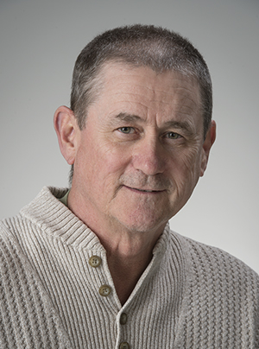
Parliamentarian
Scott Gorman
Department of HHPR
Pittsburg State University
Pittsburg, KS
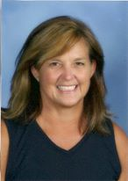
Member at Large
Jill Cundiff
Lakewood Middle School
Overland Park, KS

Convention Special Speakers

Meggin DeMoss –SHAPE America Central District President

Dennis Docheff – Board of Director of SHAPE America – Past NASPE President

Ellen Abbadessa and Vicki Skaar Johnson – Award winning teachers from Arizona and
Minnesota

Shelly Hoffman – National Elementary Teacher of the Year

Diane Wyatt – National Middle School Teacher of the Year

Diane Titterington – SHAPE America Central District Health Educator of the Year

Rhonda Holt – National Elementary Teacher of the Year

Rick Pappas – Central District Teacher of the Year

Jim Brown – National Jump Rope for Heart award winner

Beau Bragg – Finalist for Kansas Teacher of the Year

Vicki Worrell- National Elementary TOY and AAHPERD Past-President

2014 KAHPERD CONVENTION PROGRAM

Pre-Convention Workshops
WEDNESDAY October 29, 2014

Pre-Convention #1 12:30 – 3:00 p.m. Room 216
The Essentials of the Presidential Youth Fitness Program Workshop
– Ellen Abbadessa & Vicki Skaar Johnson
The Essentials of the Presidential Youth Fitness Program Workshop is a supplemental professional development opportunity designed to provide the physical education teacher with the knowledge and tools to participant in this national program. This 4-hour, in-person workshop, provides physical education teachers with 5 foundational elements needed to implement the program in their school; perfect for those just getting started.

Pre-Convention #2 12:00 – 4:00/5:00 p.m Room 215/Gym C
Right on Target with the National Archery in Schools Program
- Joyce Ellis and KDWP
This half day program leads to full certification as a National Archery in Schools Basic Archery Instructor. Joyce Ellis and her KDWP colleagues Bob Funke and Dan Moiser will be your presenters. Come and enjoy the program.

THURSDAY: 8:30 – 9:20 a.m.
Session 1
For: Middle and High School
Workout to TABATA | GYM A
Brandon Wolff And Andrew Cherry
TABATA is a fitness workout timer. We will show how we implement it for middle and high school students. This is great way to get weight training and cardiovascular at the same time.

Session 2
For: Middle School, High School, College and Health
Teaching with Polar GoFit Heart Rate and Fitness Assessment | GYM B
Ali Young and Jean Drennan
Learn how to incorporate Polar Technology that will display live heart rates for up to 40 users on your iPad. This will allow you to track your student’s fitness assessment data and help individualize every activity to show student growth. And, aide in fulfilling standards based grading and teacher evaluation requirements.

Session 3
For: Elementary School through College
Multi-Cultural Fitness games | GYM C
Shelly Grimes and PSU Students
This circuit style presentation will engage P.E. Teachers from Elementary to High school in learning new games from around the world, such as England, Germany, South America and more.

Session 4
For: Elementary and Middle schools
Sport Stacking with Speed Stacks: Teach the 3-3-3, 3-6-3 and Cycle Stacks! | Dance Studio
Jackie Hall , Randy Suddarth and Jill Meyer
Learn the 3-3-3, 3-6-3, and Cycle Stacks. Training tips and activities to enhance stacking skills will dbe demonstrated. Participants will receive FREE stacking instructional materials.

Session 5
For: K through 12.
Preparing Your Substitute Teacher: F.I.L.E. I.T. | Room 215
Dennis Docheff
This session will provide attendees with six specific ideas for teachers to use when preparing for a substitute teacher. Don’t wait until you need it; prepare the lesson early, prepare the students you leave behind, and prepare your sub for success!

Session 6
For: Pre K through 12
Student Growth Measures for Teacher Evaluation  Steve Brown | Room 216
This session will review the default student growth measures for physical education (fitnessgram), the six criteria for locally created assessments, and the potential use of PE Metrics. Participants will be encouraged to share ideas and what they are doing in their respective districts. This open discussion may be beneficial for practicing teachers, student teachers, and PETE faculty.

Session 7
For: College
The Modern Recreation / Physical Education Building  Bill Stobart, John Oppliger, and Rob Hefley | Room 217
More colleges and universities are building new buildings for recreation and physical education. This presentation will describe the procedures and precautions of planning and maintaining a modern recreation / physical education building. Trends for future recreation facilities will also be discussed.

THURSDAY: 9:30 – 10:20 a.m.
Session 8
For: Elementary and Middle Schools
Instant Activity – Challenge Them As They Come In The Door | GYM A
Meggin DeMoss
Fun challenging and easy to set up instant activities for all ages. Make the beginning of your class a relaxing time for you and your students.

Session 9
For: Middle and High Schools
Netball | GYM B
Arianne Seidl
Learn the objectives, rules, and benefits of playing the fast pace game of Netball in the middle and high school physical education setting. Netball resembles basketball and handball.

Session 10
For:
PYFP in-person training | GYM C
Jill Southernland and Ellen Abbadessa
This 1 hour session will provide you with the information on the 5 foundational elements needed to successfully implement the Presidential Youth Fitness Program in your school. An overview of PYFP, Health-related Fitness, Assessment, Recognition, and Communication will be provided.

Session 11
For: Elementary
Rhythm and Dance Activities to Enhance Skills | Dance Studio
Janice Jewett, Julia Spresser, Jenna Wendt and Christina Aiello
Experience fun and unique ways that introduce and enhance basic skills that can be transferred to sports, motor skills, functional fitness and fun. The music selections for this session won’t disappoint and add another element to the total experience!

Session 12
For K-12 Health/ PE----need to change
The First 9 weeks | Room 216
Kelsey Nelson
This session will cover information about the first 9 weeks of teaching during your first year. We will share tips and pointers on job searching, student teaching, the prep work we did prior to starting teaching and what the first 9 weeks of having your own classroom is like. The audience we would like to target would be the college students, student teacher, or anyone in their first year of teaching. We would also encourage long time teachers to join to share their wisdom.

Session 13
For: Middle and High School.
Incorporating Martial Arts Into Your Classroom | Room 217
Candee Stuchlik
This session will provide information about how Wichita Heights High School is incorporating kickboxing into their curriculum. Participants will discuss the growing world of Martial Arts, and how we can help introduce our students to this growing art.

THURSDAY: 10:30 – 11:20 a.m.

Session 14
For: Elementary
Integrating CCSS into the PE Classroom | Gym A
Jim Brown
Examples of activities that will help teachers integrate core subjects into their PE curriculum

Session 15
For: Everyone
Get your K-Game on!! | Gym B
Karla Stenzel
The fun and exciting game of Kan Jam will be presented along with ways to adapt it to a Physical Education setting i.e. double classes, varying ages of students, etc. This disc throwing sport is fast-paced, interactive and easy to learn. Kan Jam can be played on land or in the pool--competitively or just for fun. Attend the session and receive the opportunity to purchase the equipment at a special convention offer.

Session 16
For: Elementary and Middle
MOVE TO LEARN: Strategies For Improving Alertness & Engagement in the Classroom! | GYM C
Liz Dobbins and Dr. Susan King
Activity session: Focusing on the Hidden Senses using as sensory approach to connect physical activity and academic performance. Experience the science behind physical activity and the benefits.

Session 17
For: Elementary
Chinese Jump Rope & Jump B and Activities: Creative and fun additions to jump rope activities  Cole Shewmake and Michael Merrie | Dance Studio
Attendees of this session well be provided an opportunity to participate in basic Chinese jump rope and jump band activities.

Session 18
For: Middle School
I have a student teacher, now what? | Room 215
Bill Gies
This session will give the cooperating teacher tools to co-op with the student teacher and college to create and effective, energized teacher. There will be handout online, links, practice and ideating to share as well.

Session 19
For: Health
Get Hip with Health | Room 216
Shelly Hoffman
Ideas presented on how to incorporate health into daily PE lessons and activities how to catch students’ attention on the importance of health and wellness. Items presented relate to dental hygiene, germs, healthy eating, nutrition, sleep, water intake, caloric intake and expenditure, etc…. Some light movement and group work within the lecture room will take place.

LUNCH in the Student Recreation Center  11:20 – 12:50 | Student Rec Center
Visit the Exhibits

8th Annual KAHPERD Joint Projects Heart Hero Rewards Luncheon
11:15 a.m. - 12:30 p.m.
Pittsburg State University Wilkinson Alumni Center
Transportation provided in front of the Student Rec Center
(By Invitation Only)

THURSDAY: 1:00 – 1:50 p.m.

Session 20
For: Elementary, Middle, Secondary, Health
“Health Class: Let’s Move It! Move it!” | Gym A
Diane Titterington
These engaging, fun activities will help to reinforce your health class lessons while getting your students’ bodies moving and their blood flowing to their brains. While most activities target K-6, many can be used with any grade, and ideas will be given for adapting the activities for various ages.

Session 21
For: Middle
PE with a Lil’ Flava! | Gym B
Sandra Ortiz
PE with a Lil’ Flava is action-packed moves using snaps, clasps, sticks and steps, plus other equipment like basketballs. PE with a Lil’Flava will incorporate throwing, catching and dribbling for skill development, plus rhythm. Having a Lil’ Flava in your class will give a variety of learners a creative way to express themselves with or without music.

Session 22
For Elementary
Grab Bag Special | Gym C
Jaime McVey
Variety of instant activities that you will be able to take home and use. Fitness activities, instance tag games, noodle activities, Geo Motion and much more. Get ready to learn something new, have fun and sweat!

Session 23
For: Dance
Tap Dance for Beginners | Dance Studio
Jenna Wendt , Janice Jewett , Julia Spresser, Shelly Grimes and Luke Catloth
Join us to learn basic tap steps that are fun for all ages. No tap shoes? No problem!

Session 24
For: K through College
Fueled UP Play 60 with Let’s Move Active Kansas Schools | Room 216
Wendy Scholten, Tara Griffin, Becky Keeley and Chant Steuwe
The session designed to show how Let’s Move Active Kansas Schools and the Fuel Up Play 60 programs work together to help schools and students become healthy active schools / individuals. Through the Fuel Up to Play 60 program sponsored by National Dairy Council and National Football League, schools can write for grant monies to assist them in their desire to have schools become healthier and more active through healthy Eating and Physical Activity plays. Learn from those who have done the program (how easy it is) and what they did with grant money they received.

Session 25
For: K Through 12
"USA Track & Field RunJumpThrow Teacher Training" | Room 217
Matthew Lydum
In this 50 minute interactive session, teachers are introduced to USA Track & Field’s RunJumpThrow program. RunJumpThrow is a skill-based and fun way of introducing children to basic movements that are important for all sports and healthy lifestyles. Wear comfortable clothing if you would like to participate in the physical activities!

Session 26
For: Technology
icreate, imove, ilearn in Physical Education! | Room 219
April Baugh
In this session, you will learn how I have incorporated ipads, as a tool for learning and creating, in my PE class. App’s included are Socrative, Qrafter Pro, Eat and Move o Matic, Coach My Video, Educreations, Counter Up, My Daily Plate, Body Organs, Crayola LCC, Showbie, iMove and many more! See how ipads can effectively be implemented in a Physical Education classroom

THURSDAY: 2:00 – 2:50 p.m.

Session 27
For: Future Professionals
How BIG Is Your Heart? Introducing the 2014-15 Collegiate Challenge | GYM A
Brenda Sharp, Julie Webb and Jayme Lindstrom
Is your HPER Club willing to show the size of its heart? If so, this session is for you! Learn about the Collegiate Challenge and how you can develop valuable skills while making a difference on your campus. Be the first HPER Club to show the size of its heart by claiming the inaugural Collegiate Challenge trophy. Bonus! Every HPER Club in attendance will receive materials to jumpstart its Collegiate Challenge.

Session 28
For: Elementary
How do I assess standards 3-5 for Intermediate and Middle School students. HELP (Helpful, Easy, legitimate, purposeful)  Meggin DeMoss | GYM B
Ideas on how to assess standards 3-5 for Intermediate and Middle School students. Using HELP (Helpful, Easy, Legitimate, Purposeful)

Session 29
For: Dance
ZOMBIE Rhythms: Dance Activities that Refuse to Die | GYM C
Joella Mehrhof
From the tombs of the cassettes come those Zombies back from the dead. Come and move to thirty years of dance and rhythmic greats now being brought to back to life with updated music and renewed energy. Easy to learn, easy to use activities that even the left-footed walking dead can teach. Come to see if one or more of your favorites have been given new life!!!!!

Session 30
For: Elementary and Middle Schools
Energize the Brain and body with Speed Stacks | Dance Studio
Jackie Hall, Randy Suddarth and Jill Meyer
Review the basics 3-3-3, 3-6-3 and cycle stacks. Experience a variety of brain energizing and body movement activities using Speed Stacks. Super-size movement Fun and Jumbos. Participants will receive FREE stacking instructional materials.

Session 31
For: Technology
Technology Treasure Trove: Professional Development for Free | Room 215
Dr. Susan King
Who would you like to have unlimited professional resources material at your fingertips? Apps. Videos, images, websites, books, activities, assessments? Learn how you can use technology and social media to tap into the latest resources from professional physical educators all over the world. Participants will leave this session with the key to a treasure trove of technological resources that can be put to use immediately.

Session 32
For: K through 12
Brain Breaks- Promoting Physical Activity Throughout the School Day | Room 216
Lauren Loucks and Amy Townsend
The Let’s Move Active Schools initiative has encouraged physical educators to become leaders in the promotion of physical activity throughout the school day. In this session, we will share ideas that can be used on a rainy day when you’ve lost your gym space or shared with colleagues for use in the classroom. These activities require minimal space and minimal equipment.

Session 33
For: Elementary, Middle, High, and College
Student Teaching. The Good, The Bad & The Best | Room 217
Casey McConnell and Shelbie Winter
With over 13 years of experience we have seen and dealt with the good, the bad and the best. We want to give highlights to all about how to make the student teaching experience valuable to the student teacher, cooperating teacher and most importantly the kids.

Session 34
For: K-12
LMAKS Summer 2014 Training Meeting | Room 205
Rhonda Holt
This meeting is for all teachers who attended the “Let’s Move! Active Kansas Schools” trainings that were held in Hays and Olathe. Updates, current information, time to meet with your mentor, and time to answer questions and concerns will take place during this time. If you attended one of these trainings, please make sure you attend this meeting.
“Let’s Move! Active Schools” Sharing Session for Higher Education Faculty
All Higher Education faculty are invited to this session to learn about changes to the “LMAS” project as well as share ideas and strategies to include Comprehensive School Physical Activity concepts as part of your curriculum.

Session 35
For: Elementary, Middle, and High Schools
Kayaking 101 | Weede Pool
Blake Taylor
Learn the basics to Kayaking and water Safety. This session will included; types of kayaks, types of paddles, types of PFD’s safety gear use, paddling techniques, and how to transport a Kayak. Please Note: kayaking program will be moved from the Weede Gym pool to the PSU College Lake if weather is excellent. The lake is just East of the football stadium and members should meet at the site of the Gorilla Village. Check in the HHPR office if the weather is in doubt and we will post a notice

THURSDAY: 3:00 – 3:50 p.m.

Session 36
For: Elementary
Common Core Integration—Fast and Easy | GYM A
Scott M. Enge
Physical Education is included in the Common Core. Learn how to incorporate CC strategies into your daily routines and still remain loyal to our PE curriculum. Using these strategies will further validate the importance of our Physical Education curriculum to other staff members, administrator and parents.

Session 37
For: Elementary
Elementary P.E. Rocks! | GYM B
Angela Redfern
Join us for various lead up games to Hockey, Frisbee, Basketball and Cup-stacking. We will also be demonstrating various Holiday themed tag games! You won’t want to miss this action packed session!

Session 38
For: K thru 12.
Team Work Works | GYM C
Andrew Cherry and Vicki Mester
Dare students to work together to reach a common goal! In this session numerous activities will be presented on how to teach teambuilding in the classroom. These activities area challenging and rewarding. They allow students of all grade levels to work in small groups, design and execute a plan, work through adversity and celebrate their successes. You will have activities to implement with your students and prove to them that teamwork works!

Session 39
For: K through 12
Let’s Move in the Classroom | Room 215
Rhonda Holt, Catherine Arella, Joan Bolt, Jill Cundiff, Todd Junker, Shellie Stahley, and Claudi Welch.
During this session numerous brain break ideas and resources will be presented as well as some tips on working with classroom teachers to include activity breaks for their students.

Session 40
For: Middle
Minute to Win it……if you can! | Room 216
Diane Wyatt
Does your gym need a little fun? Come and explore effective activities and concepts and have fun at the same time. Creative activities that will keep your students moving through maximum participation, improving fitness, motor development, and develop team concepts. Ideas for integrating technology, addressing common core through using iPads (animoto, i movie) for creating mini photo reports of activity.

Session 41
For: Recreation
Knots-Knots and even more Knots! | Room 217
Scott Gorman, Ryan Metcalf, Cole Shewmake, and Mike Carper
Learn hands-on the various knots used for camping, fishing, climbing and just plain old-fashioned ever day life! Have you ever played a big fish to the bank only to have it get away at the last second? AAAAAAHHHHHHH! Learn how to prevent this common problem. Fun useful fishing and camping knots will be taught that you will use for the rest of your highly active, outdoor, adventurous life!

Session 42
For: College
Higher Education Roundtable | Room 219
Bill Stobart, Laura Covert, Lindsey Gordon, Mica Rosenow, and Hillary Dickey
An informal discussion concerning various topics in higher education. Topics discussed will include: the modern college student, the changing college faculty, technology in the classroom, on-line classes, and problems encountered by both students and faculty in higher education. Attendees will be given the opportunity to discuss other topics of interest.

FRIDAY BREAKOUT SESSIONS: 8:30 – 9:20 a.m.

Session 43
For: Elementary
Catching and Throwing games: Their importance to muscle eye fitness | GYM A
Scott Enge
Catching/throwing skills and games are not only important for sports, they enhance muscle eye fitness, reading skills, hand eye coordination and connect the two hemispheres of the brain through cross lateralization

Session 44
For: Upper Elementary, Middle, and High School
Hantilation for Physical Education | GYM B
Bill Schrant and Karl Ely
Hantis is an exciting new sport that combines elements of table tennis, 4-square, and handball. The game is great for upper elementary, middle school, high school, and adults. We will show you how to play, and more importantly a progression you can use with your students to help them be successful, and adaptations for students who struggle.

Session 45
For: Adaptive
APE Activity: Review of definitions & examples of modified games & activities | GYM C
Michael Merrie and Cole Shewmake
This session will provide a review of adapted PE definitions, a brief discussion of different disabilities/ categories, and will provide an opportunity to participate in modified games and activities.

Session 46
For: Middle, High, Adaptive, and Dance
Aerobics & Fitness: A Zumba Inspired Cardio Party! | Dance Studio
Ashley Blanton
This session will feel like a party! You don’t even have to know how to dance! Anyone and everyone will be successful in this session. This session will incorporate Zumba basics, strength training, flexibility, and cardiovascular endurance intervals to music teens enjoy. If you teach middle school or high school, you must visit this session because this will be a lesson your students will beg you to teach.

Session 47
For: High School
NASP: A Great Fit For Any Program | Room 216
Joyce Ellis and Gary Keehn
This session will introduce participants to the National Archery in the schools program in Kansas. Participants will learn more about how archery can be used to develop student fitness in Physical Education as well as academic skills in other content areas. Participants will have the opportunity to ask the state coordinate or any questions they might have about getting a program started in their school.

Session 48
For: Everyone.
Pinamonti Facility Tour | Room 217
Bryce Winklepleck
Pinamonti Wellness Center is a brand new state of the art facility in Pittsburg, KS offering much more than just a place to workout. The wellness center is packed with high-tech equipment allowing for immediate feedback regarding your workout; certified personal trainers and group fitness instructors; licensed massage therapists; no-entry pool; wi-fi cafe; and soon-to-be rock climbing wall.

Session 49
For: Elementary
Perceptions of children toward physical fitness | Room 219
Rich Bomgardner
Children from different school environments completed two physical activity self-efficacy scales which was compared to their physical fitness tests. Results evaluated the environment and physical fitness tests to determine any correlation to the children’s perceptions.

Session 50
For: Middle School
Bicycle Safety | Assembly Hall Gym
Denise Barber
The bicycle safety curriculum from SHAPE AMERICA for grades 6-12 will be presented.

FRIDAY: 9:30 – 10:20 a.m.

Special Session 51
For: Elementary
Integrating the College Career Ready Standards (Common Core) into Elementary Physical Education | GYM A
Rick Pappas
This session will focus on integrating the Kansas College Career Ready Standards (adapted from the Common Core Standards) for Math and English Language Arts into elementary Physical Education

Session 52
For: Elementary
NOW WHAT? Classroom Management tips from the Real World to help the Rookie Teacher | GYM B
Julie Webb
Your degree is done and you’ve got the job. All of that college preparation has you ready…or does it? Learn some tips and strategies to help you the first day, the first week, and your first year. Special Bonus! Everyone who attends this session will learn the simple recipe to teach kids how to jump rope in ten simple steps. Silence the “I can’t do it” with your amazing knowledge and earn the trust of your students. Yes! You are a trained professional!

Session 53
For: Elementary
Fitnessgram Testing: Effective and Efficient Strategies | GYM C
Mark Thompson, Claudia Welch, and Abby Ungles
Two physical education teacher who have extensive experience with fitnessgram will demonstrate effective and efficient strategies for conducting testing on components outlined as part of the K-FIT program. Attendees will have an opportunity to observe and participate in demonstrations that emphasize best practices for fitness testing. Emphasis will be placed on testing at both the elementary and middle/ high school levels. The presentation will also address the incorporation of technology in conducting and recording fitness test data. Attendees will leave with an understanding of how to effectively incorporate fitness testing into their PE programs and how K-FIT can help further the teacher’s, schools and district’s goals.

Session 54
For: Dance
Mix it up with Zumba | Dance Studio
Julia Spresser, Janice Jewett, Shelly Grimes, Jenna Wendt & Bridgett Lancaster
Encourage participant interaction and participation with these Zumba routines. Expect hand jives, vocal responses, partner play, break-out dance battles, Cumbai costume partner dance etc. Come ready to sweat and make new friends. Choreography maps and music links included.

Session 55
For: Elementary, Middle, High and Health
This Ain’t Yo’ Mama’s Health Class | Room 215
Diane Titterington
Spice up your classroom health lessons with some fresh ideas, games, and activities, as well as some twists to old ones. Also, hear ideas on how to start or expand a regular health curriculum in your school and how to get your administration excited about it. Although most activities will be targeted for elementary health classes, thoughts will be shared of how to easily adapt the games/activities for all grade levels.

Session 56
For: College
Let’s Move! Active Schools” Sharing Session for Higher Education Faculty | Room 217
Rhonda Holt
All Higher Education faculty are invited to this session to learn about changes to the “LMAS” project as well as share ideas and strategies to include Comprehensive School Physical Activity concepts as part of your curriculum

Session 57
For: Health
Importance of Functional Movement | Room 219
Bryce Winklepleck and John Tricks
The past few decades there has been a major decline in physical activity among children of all ages. This results in a decrease of functional movement that will hinder quality of life as children mature. This session will cover the decline of functional movement and movement patterns that need to be implemented into daily life for children

Session 58
For: K-12
Create Activities on the Spot: Your Chance to Develop New Games! | Assembly Hall Gym
Hillary Dickey, Stuart Jeck, Mica Rosenow, Lindsey Gordon, Taylor Zingg and Jake Dollar
Participants will be put in small groups and given pieces of equipment typically used in a Physical Education class of any level k-12. They will be given a few minutes to come up with a creative game or fitness activity working as a group and then presenting it to the rest of the session attendees for actual play. The goal is to see which group comes up with the best activity which would keep a classes attention, keep them active and of course have fun.

FRIDAY: 10:30 – 11:20 a.m.

Session 59
For Elementary
Physical Activity Used or Withheld for Punishment…Is It Happening in Your School? | GYM A
Beau Bragg
How often do you hear “you owe me 10 minutes of recess”, “You owe me 5 laps at recess”, or “you need to complete your work instead of go to PE”? What can you do as the Physical Activity leader in your school? We know why physical activity is important, but do your colleagues? I will provide you with a few strategies to get the conversation started, resources to support physical activity in schools, justification for eliminating the above statements, and alternative to withholding PA or using it as punishment Oh and now worries we will be up and moving!

Session 60
For: Health
The (Icha) Bod Shop | GYM B
Tiffany Dirks
This elementary health and fitness curriculum is aligned with NASPE and state standards. Students compare their bodies to cars and learn to take care of the most important machine they will ever own with the help of Head Mechanics, the Physical Education specialists. The different components of the 4 “departments” in the bod shop help teach students’ the importance of both healthy choices and physical fitness / activities that they will use throughout their lifetime to keep their “machines” (bodies) in top performing condition.

Session 61
For: Middle school thru Adult Fitness
Cross Fitness Challenge | GYM C
Shelly Grimes
This session is a participation required, sweaty workout!!! The Cross Fitness Challenge session will get your heart rate pumping’ with floor cross training routines, then progress to a circuit style workout including various P.E. and equipment utilized to build endurance and strength including the BOSU ball, INDO boards, ropes, bands, and balls. This class can be taught at the middles school to college age level and /or in a health club setting. If you are attending the conference and just need a good workout for the day….drop by and take this session.

Session 62
For: Coaching
Getting Ready to Coach: Six P’s That Get You Prepared | Room 215
Dennis Docheff
As young coaches enter the profession, there are a lot of people who may questions themselves—“Will I be ready?” This session provides young coaches with ideas on how to prepare for that first coaching job. Items for discussion include: Philosophy, Professionalism, Planning, Practice, Promotion, and Play.

Session 63
For: Middle and High School
Differentiated Instruction in Physical Education | Room 216
Jeff and Jen Zimmerman
Learn about differentiating instruction in physical education by sorting the students by fitness level to tailor their workouts and maximize results

Session 64
For Elementary, Middle, Secondary, Future Professionals, Recreation
Highlights for Higher Education from KSDE | Room 219
Mark Thompson
Come hear the latest updates from the Kansas State Department of Education in regards to health education and physical education. Updates will include information on the status of revising the Health Education and Physical Education Model Curricular Standards, steps to provide K-FIT training for pre-service teachers, how fitness testing and Let's Move! Active Schools elements are being incorporated into Kansas wellness policy guidelines, and more.

Session 65
For Elementary, Middle, High, College and Adaptive
School Tennis—Fun, Easy, No Courts Required! | Assembly Hall Gym
Jaren Glaser and Jodi Gordon
Participate in an activity demonstration on how to offer tennis in your PE class, after school program, or at recess, without having prior tennis experience. No courts are required, so schools can effectively offer tennis in a variety of settings. Also, experience the ease of using “right-sized” equipment for kids that makes offering tennis easy for large of small groups.

Closing Ceremony
11:30 a.m.
Finals KAN-JAM Tourney
Major Door Prize Giveaway
($550 Hybrid Bicycle)
(DELL Computer)

(must be present to win)

KAHPERD Exhibitors

Advanced Exercise Equipment
Jeff Paxton
10291 W. 295th St.
Louisburg, KS 66053
877-764-8981
jpakman@mokancomm.net

Archery In the Schools
Gary Keehn
2840 254th Rd.
Soldier, KS 66540
785.834.2075
archeryintheschools@ksoutdoors.com

American Heart Association
Angie Galindo
6800 W 93rd St.
Overland Park, KS 66212
816-918-5528
angie.galindo@heart.org

Brax Fundraising
Jen Pospisil
355 W. 8th
Cortland, NE 68331
402-450-6122
jenp@braxltd.com

Central District Shape
Vicki Worrell
1200 Commercial, Campus Box 4013
Emporia, KS 66801
605.574.4616
sjscherrer@gmail.com

Cleveland Chiropractic College
Dr. Karen Doyle
10850 Lowell Ave
Overland Park, KS 6210
913-234-0600
karen.doyle@clevelend.edu

Fort Hays
Glen McNeil
600 Park St
Hays, KS 67601
785-628-5296
gmcneil@fhsu.edu

Goodheart-Willcox Publisher
Don Blazer
18604 W. Creek Dr.
Tinley Park, IL 60477
888-409-6108
dblazek@g-w.com

Image Sport
Jon Linder
1115 SE Westbrooke Dr.
Waukee, IA 50263
515-987-7699
lsmith@imagesport.com

KAHPERD Model School Exhibit
Michelle DiLisio
Chanute High School 1501 W. 36th St
Chanute, KS 66723
620-432-2510
dilisiom@usd413.org

Midwest Dairy Council
1804 NW Parkway
Wichita, KS 67212

Polar Health First
Jean Drennan
13260 Switzer
Overland Park, KS 66213
913.239.3456

Skatetime School Programs/C’motion
Jeania Luber
P.O. Box 32612
Oklahoma City, OK 73123
405-771-4792
jeanialuber@luber.com

Southwest Dairy Museum
P.O. Box 936
Sulphur Springs, TX
903-439-6455
cmckinney@southwestdairyfarmers.com

Speed Stacks, Inc.
Pola Metz
11 Inverness Way South
Englewood, CO 80112
303.663.8083

US Tennis Association – Missouri Valley
Susan Riemann
457 – A South Clay Ave.
St. Louis, MO 63122
913-322-4836
riemann@movalley.usta.com

Special Thanks

Midwest Dairy Council for sponsoring the Thursday morning nutrition break.

Crawford County Convention and Visitors Bureau for sponsoring the convention

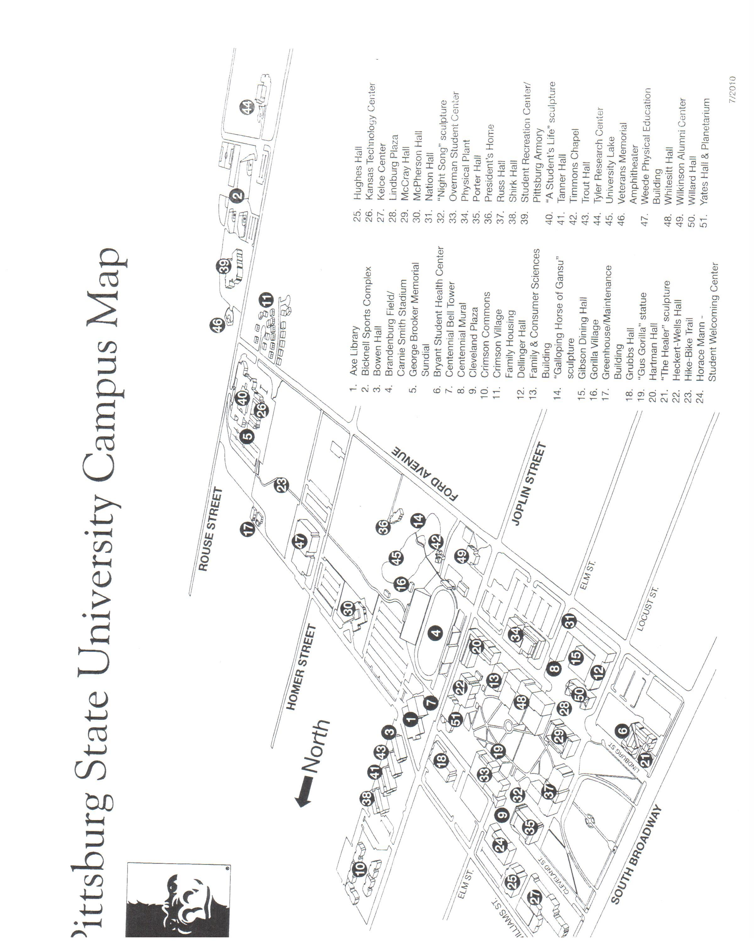
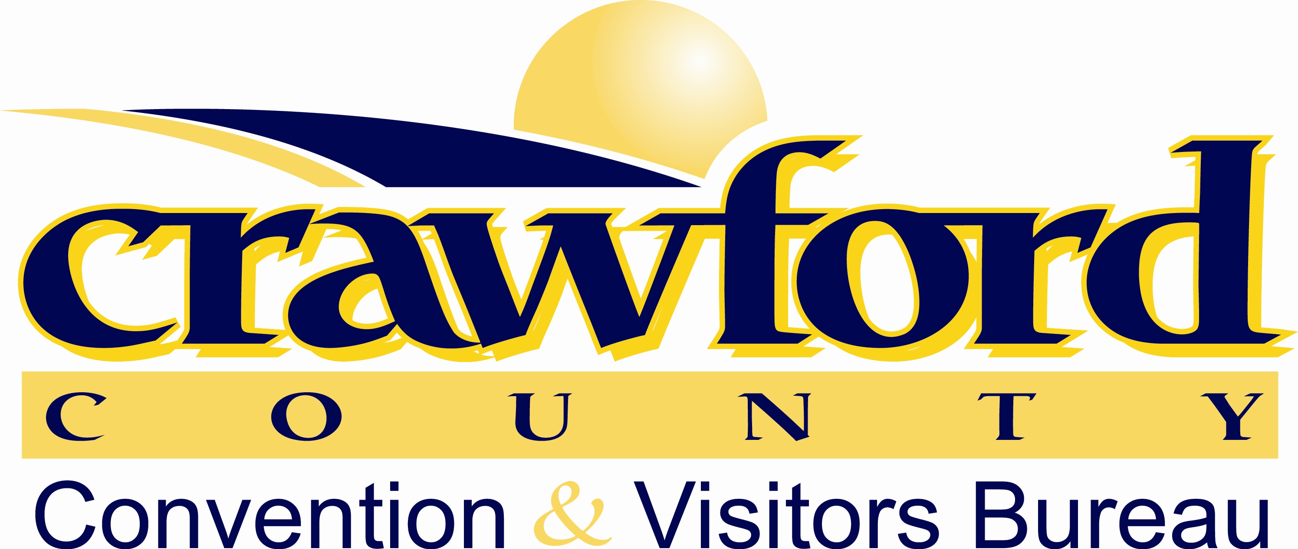
Pittsburg State University Campus Map
See You at the 2015 KAHPERD Convention

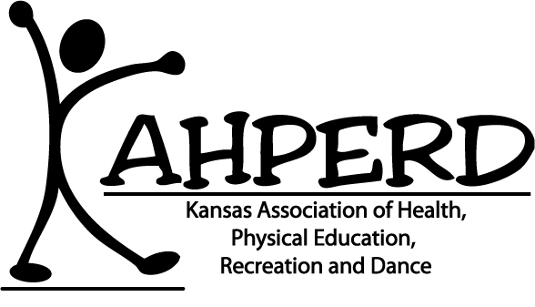
Wichita State University

