Climbing Wall Route Setting Fundamentals
It’s a good idea to move the location of your hand holds periodically to keep the climbing wall interesting and challenging for climbers over time. In doing so, you can create specific climbing routes, of varying difficulty levels, for climbers to try.
Many people wonder "What is a climbing route?" and "How do I go about setting climbing routes?" We are here to help!
What Is a Climbing Route?
A climbing route is a specific path the climber must follow to reach the top, or end, of a climb.
How Are Climbing Routes Marked?
Routes can be marked with tape next to holds that are on the route. Or the same color hand hold can be used throughout a route. Many climbing walls include color-coded hand holds which makes it easier to set routes by color. Each color corresponds to a certain difficulty level enabling route setters to set climbing routes of varying degrees of challenge.
What Should I think about before Setting a Climbing Route?
- Age and ability of climbers
- Size(s) of climbers. How long are their legs and arms?
- Are holds at the beginning and end of the climbing wall positioned to allow climbers to get on and off the wall easily?
- How you position a hold on the climbing wall can affect its difficulty level. Generally there is an easier and harder way to position the climbing hold on the rock wall.
What Makes a Good Rock Climbing Route?
- Safety
  - The climber should not be required to climb too high (on a Traverse Wall®) or to make moves that put him/her in awkward or off-balance positions
  - The route should be climbable for people of varying heights
- Variety
  - Involves a variety of different climbing moves
  - Involves a variety of hand and foot placements
  - Uses most of the climbing wall
  - Requires some interesting or unusual moves
- Difficulty Level
  - The difficulty level should be consistent throughout the entire route, from start to finish
  - Keep the skill and experience of participants in mind and create routes that challenge and engage, but that do not frustrate
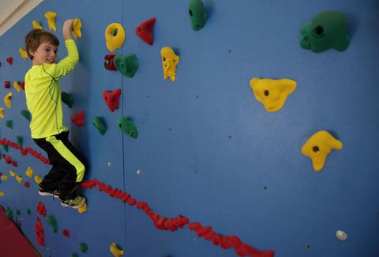
What Should I Avoid When Setting Climbing Routes?
- Too challenging, for example, with not enough holds on the route making it too hard to get from hold to hold
- Boring with too many of the same climbing moves
How do I Get Started Route Setting on a Traverse Wall®?
- Unpack hand holds and separate them by size and color.
- Begin with the largest holds. Mount holds that will be used for feet and for hands. Space them to create a beginner-level route that will not require much stretching or challenging moves. Vary the location of the shapes. Be sure they span entirely from one end of the wall to the other. Try it out as you create the route to make sure it’s climbable. Keep the age/size/reach of climbers in mind.
- Next mount the medium holds in a similar way, creating an intermediate-level route. Next mount the smallest holds in a similar way, creating a more advanced/challenging route.
How often should I set new climbing routes?
This is a personal decision that depends on how much your climbing wall is used and the needs of your climbers. Some schools never change their routes, while other change them anywhere from 1-3 times a year. Keep in mind that you can rotate the hand holds 90-180 degrees to add some variation to a route without having to completely remove and move holds.
What If I need More Help Setting Climbing Routes?
There are many books and resources available. If you own a wall from Everlast Climbing and would like more detailed guidance with route setting, they offer a Traverse Wall Route-Setting Guide for purchase. This one-of-a-kind guide takes you step-by-step through the route setting process. It includes an introduction to the route setting process, route maps, hand hold installation instructions and other resources. The route maps show exactly where to place hand holds, which greatly simplifies the route setting process. Keep in mind that the guide is compatible only with Groperz Route-Setting Hand Holds and certain climbing walls manufactured by Everlast Climbing.

About Everlast Climbing
Everlast Climbing is committed to improving youth fitness with dynamic and innovative products that engage children and inspire physical activity. The company is headquartered in Minneapolis, MN, and is a PlayCore company. More information is available about Everlast Climbing at www.everlastclimbing.com.

