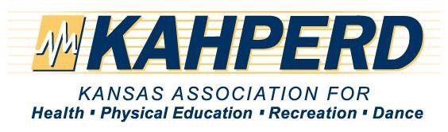

Sponsorship Levels

Annual conference Sponsorship Packages are a great way to leverage your advertising dollars for an extended timeframe. Not only will you receive visibility during the convention, but you will also gain added exposure in the convention promotions leading up to the event. Select from our pre-packaged Platinum, Gold, Silver, or Bronze levels, or e-mail the convention manager to customize a package just for you!

Platinum Sponsorship $5000
Your business name and logo prominently displayed in advertisements including:
- Your business link for one year on KAHPERD website.
- Main signage at annual convention
- Free booth in the exhibit hall at the annual convention
- Inclusion in all marketing publications, announcements and emails
- One free insert in the annual convention participants’ packet
- One year free link to the KAHPERD website (You will be responsible to provide the information for the ad and space on the website)
The Kansas Association for Health, Physical Education, Recreation, & Dance Annual Convention will be held on November 9-10th, 2023 at the Century II Convention Center in Wichita, Kansas .
Exhibits will be from 8:00m-4:00pm on Thursday, November 9th. Please contact Kim Morrissey, Convention Manager at: kmorrissey917@gmail.com or check our website for more details at: www.kahperd.org
A special discounted hotel rates have been secured at the Drury Plaza Hotel Broadview, Hyatt Regency, Fairfield and Home2Suites.

- Sponsors name, logo and/or flyer sent to membership in electronic newsletters, 3 issues per year
- Speak at the Awards Ceremony
- Five minute appropriate, approved video shown at the start of the Awards Ceremony
- One 50 minute session at the convention, if appropriate

Gold Sponsorship $2500
Your business name and logo prominently displayed in advertisements including:
- Inclusion in all marketing publications, website announcements and emails
- One free, full-page ad in one KAHPERD Journal (to be used within one year of the event)
- One year free link to the KAHPERD website (You will be responsible to provide the information for the ad and space on the website)
- Sponsors name, logo and/or flyer sent to membership in electronic newsletters, 3 issues per year
- Speak at the Awards Ceremony
- Free booth in the exhibit hall at the annual convention

Silver Sponsorship $1000
Your business name and logo displayed in advertisements
- Inclusion in all marketing publications, website announcements and emails
- One free, half-page ad in one KAHPERD Journal (to be used within one year of the event)
- Six months free link on the KAHPERD website (You will be responsible to provide the information for the ad and space on the website)
- Sponsors name, logo and/or flyer sent to membership in electronic newsletters, 3 issues per electronic newsletters, 3 issues per year

• Free booth in the exhibit hall at the
annual convention
Bronze Sponsorship $500
Your business name and logo displayed in advertisements
- Inclusion in all marketing publications, website announcements and emails
- Free booth in the exhibit hall at the annual convention

